|  |  |  |  |  |  |  |
| --- | --- | --- | --- | --- | --- | --- |
| **Academic Year: 2024- 25** | | | | **A green check mark on a white background  Description automatically generatedSemester: Odd / Even (Tick anyone)** | | |
| **School/Department/Centre:** | | **SOET** | | | | |
| **Programme:** | | **BTech CSE** | | | | |
| **Semester & Section** | | **1F** | | | | |
| **Roll No.:** | | **24CSU265** | | | | |
| **Name of Student:** | | **BUSHRA FATIMA** | | | | |
| **Note**:   1. Please provide details of any activities or participation that took place after the last GP evaluation. *Activities prior to the last GP evaluation will not be considered. 2. Remember to bring testimonials as proof of all details provided. If you cannot produce testimonials during the evaluation, the information will be deemed incorrect and will not be considered. 3. Ensure that the student's e-portfolio is fully updated for the GP evaluation. | | | | | | |
| **Part A** | | | | | | |
| **1. APTITUDE TEST (To be conducted by university [*offline/online/third-party portal*])** | | | | | | |
| **(A) Maximum Marks: _________** | | **(B) Marks Obtained: __________** | | | | **(C) Convert it out of 50: _________** |
| **GP Score in Part A (*Score as per (C) out of 50*):** | | | | | |  |
|  | | | | | | |
| **Part B** | | | | | | |
| **2. CO-CURRICULAR ACTIVITIES** | | | | | | |
| **2.1 Self-Study and Upskilling:**   * **Advanced Skills Development:** Engagement in activities that enhance specialized skills and knowledge in your field. * **Tinkering Lab:** Participation in hands-on projects and experiments to apply theoretical concepts practically. * **Incubation Activities:** Involvement in initiatives that foster innovation and entrepreneurship. * **Online Courses Beyond Curriculum:** Enrollment in online courses to gain knowledge and expertise beyond the standard curriculum. | | | | | | |
| **#Name of the Activity** | **\*Duration & Dates** | | **Level of Participation** | | **Result with Proof** | |
| **Matlab Course on Calculations with vectors and matrices** | **2Hours**  23/11/24 | | **Participated** | | **Successfully Participated. Uploaded in Annexure TE 4** | |
| **Matlab Course on Matlab Coder Onramp** | **2Hours**  **23/11/24** | | **Participated** | | **Successfully Participated. Uploaded in Annexure TE 4** | |
| **Science Exhibition** | **20 November, 2024** | | Participated | |  | |
| **GP Score in 2.1 (*Score out of 15*):** | | | | |  | |

|  |  |  |  |
| --- | --- | --- | --- |
|  | | | |
| **2.2 Technical/Professional:**   * **Membership in Technical Societies:** Join and actively participate in professional and technical organizations related to your field. * **Participation in Events:** Attend conferences, workshops, seminars, and other events to stay updated with industry trends and network with professionals. * **Professional Activities:** Engage in activities that enhance your technical knowledge and professional skills, such as contributing to technical publications or presenting at conferences. | | | |
| **#Name of the event** | **\*Duration & Dates** | **Level of Participation** | **Result** |
| **Group Discussion in Do UFO Sightings confirm the existence of Aliens** | **12th September 2024** | **Participated** | **Successfully Participated. Uploaded in Annexure TE 1** |
| **UN Quiz Blitz** | **23rd October 2024** | **Participated** | **Successfully Participated. Uploaded in Annexure TE 1** |
| **Find My Other Self** |  | **Participated** | **Successfully Participated. Uploaded in Annexure TE 2** |
| **Smiles And Sunshine NGO Visit** | **7th September 2024** | **Participated** | **Successfully Participated. Uploaded in Annexure TE 2** |
| **NRC Guest Lecture** | **24th September 2024** | **Participated** | **Successfully Participated. Uploaded in Annexure TE 3** |
| **Astronomy Visit 2.0** | **14th September 2024** | **Coordinated** | **Successfully Participated. Uploaded in Annexure TE 3** |
| **Green Innovation Unleashed** | **17th October 2024** | **Participated** | **Successfully Participated. Uploaded in Annexure TE 4** |
| **Green Innovation Unleashed** | **17th October 2024** | **Coordinated** | **Successfully Participated. Uploaded in Annexure TE 4** |
| **GP Score in 2.2 (*Score out of 15*):** | | |  |
| **GP Score in Part B (*Score as per (2.1+2.2) out of 30*):** | | |  |

#Add extra sheet if needed.

|  |  |  |  |
| --- | --- | --- | --- |
| **Part C** | | | |
| **3. Sports/Cultural Activities and Outstanding Achievements:**   * **Participation in Sports:** Actively participate in sports activities and events, demonstrating teamwork and physical fitness. * **Engagement in Cultural Activities:** Involve in cultural events, showcasing talents in arts, music, dance, or drama. * **Outstanding Achievements:** Highlight any significant accomplishments or awards received in sports, cultural activities, or other areas. | | | |
| **#Name of the event** | **\*Duration & Dates** | **Level of Participation** | **Outcome/Remarks** |
|  |  |  |  |
| **GP Score in Part C *(Score out of 10)*:** | | |  |

#Add extra sheet if needed.

|  |  |
| --- | --- |
|  | |
| **Part D** | |
| 1. **Others**   **4.1 General Awareness/Soft Skills:**   * + **General Awareness:** Demonstrate a broad understanding of current events, global issues, and industry trends.   + **Soft Skills:** Exhibit strong communication, teamwork, problem-solving, and leadership skills.   + **Evaluation:** Comments and marks to be filled by the evaluation committee based on VIVA performance. | |
| **GP Score in 4.1 *(Score out of 5):*** |  |
| **4.2 Attendance in Mentor-Mentee Meetings:**   * **Regular Participation:** Attend mentor-mentee meetings held every fortnight consistently. * **Engagement:** Actively engage in discussions, seeking guidance and feedback from mentors. * **Record Keeping:** Maintain accurate records of attendance and participation in these meetings. | |
| **GP Score in 4.2 *(Score out of 5):*** |  |
| **GP Score in Part D *(Score as per 4.1+4.2 out of 10)*:** |  |

|  |  |  |
| --- | --- | --- |
| **Total Marks Obtained = __________________ out of 100.** | | |
| Evaluation Committee Members: (*As constituted by concerned School/Department/Centre*) | | |
| **Member 1:**  **Date:** | **Member 2 (Mentor): Date:** | **Member 3: Date:** |

INDEX - Annexure TE1

Name of the Activity: **Group Discussion in Do UFO Sightings confirm the existence of Aliens**

Name of the Activity: **UN Quiz Blitz**

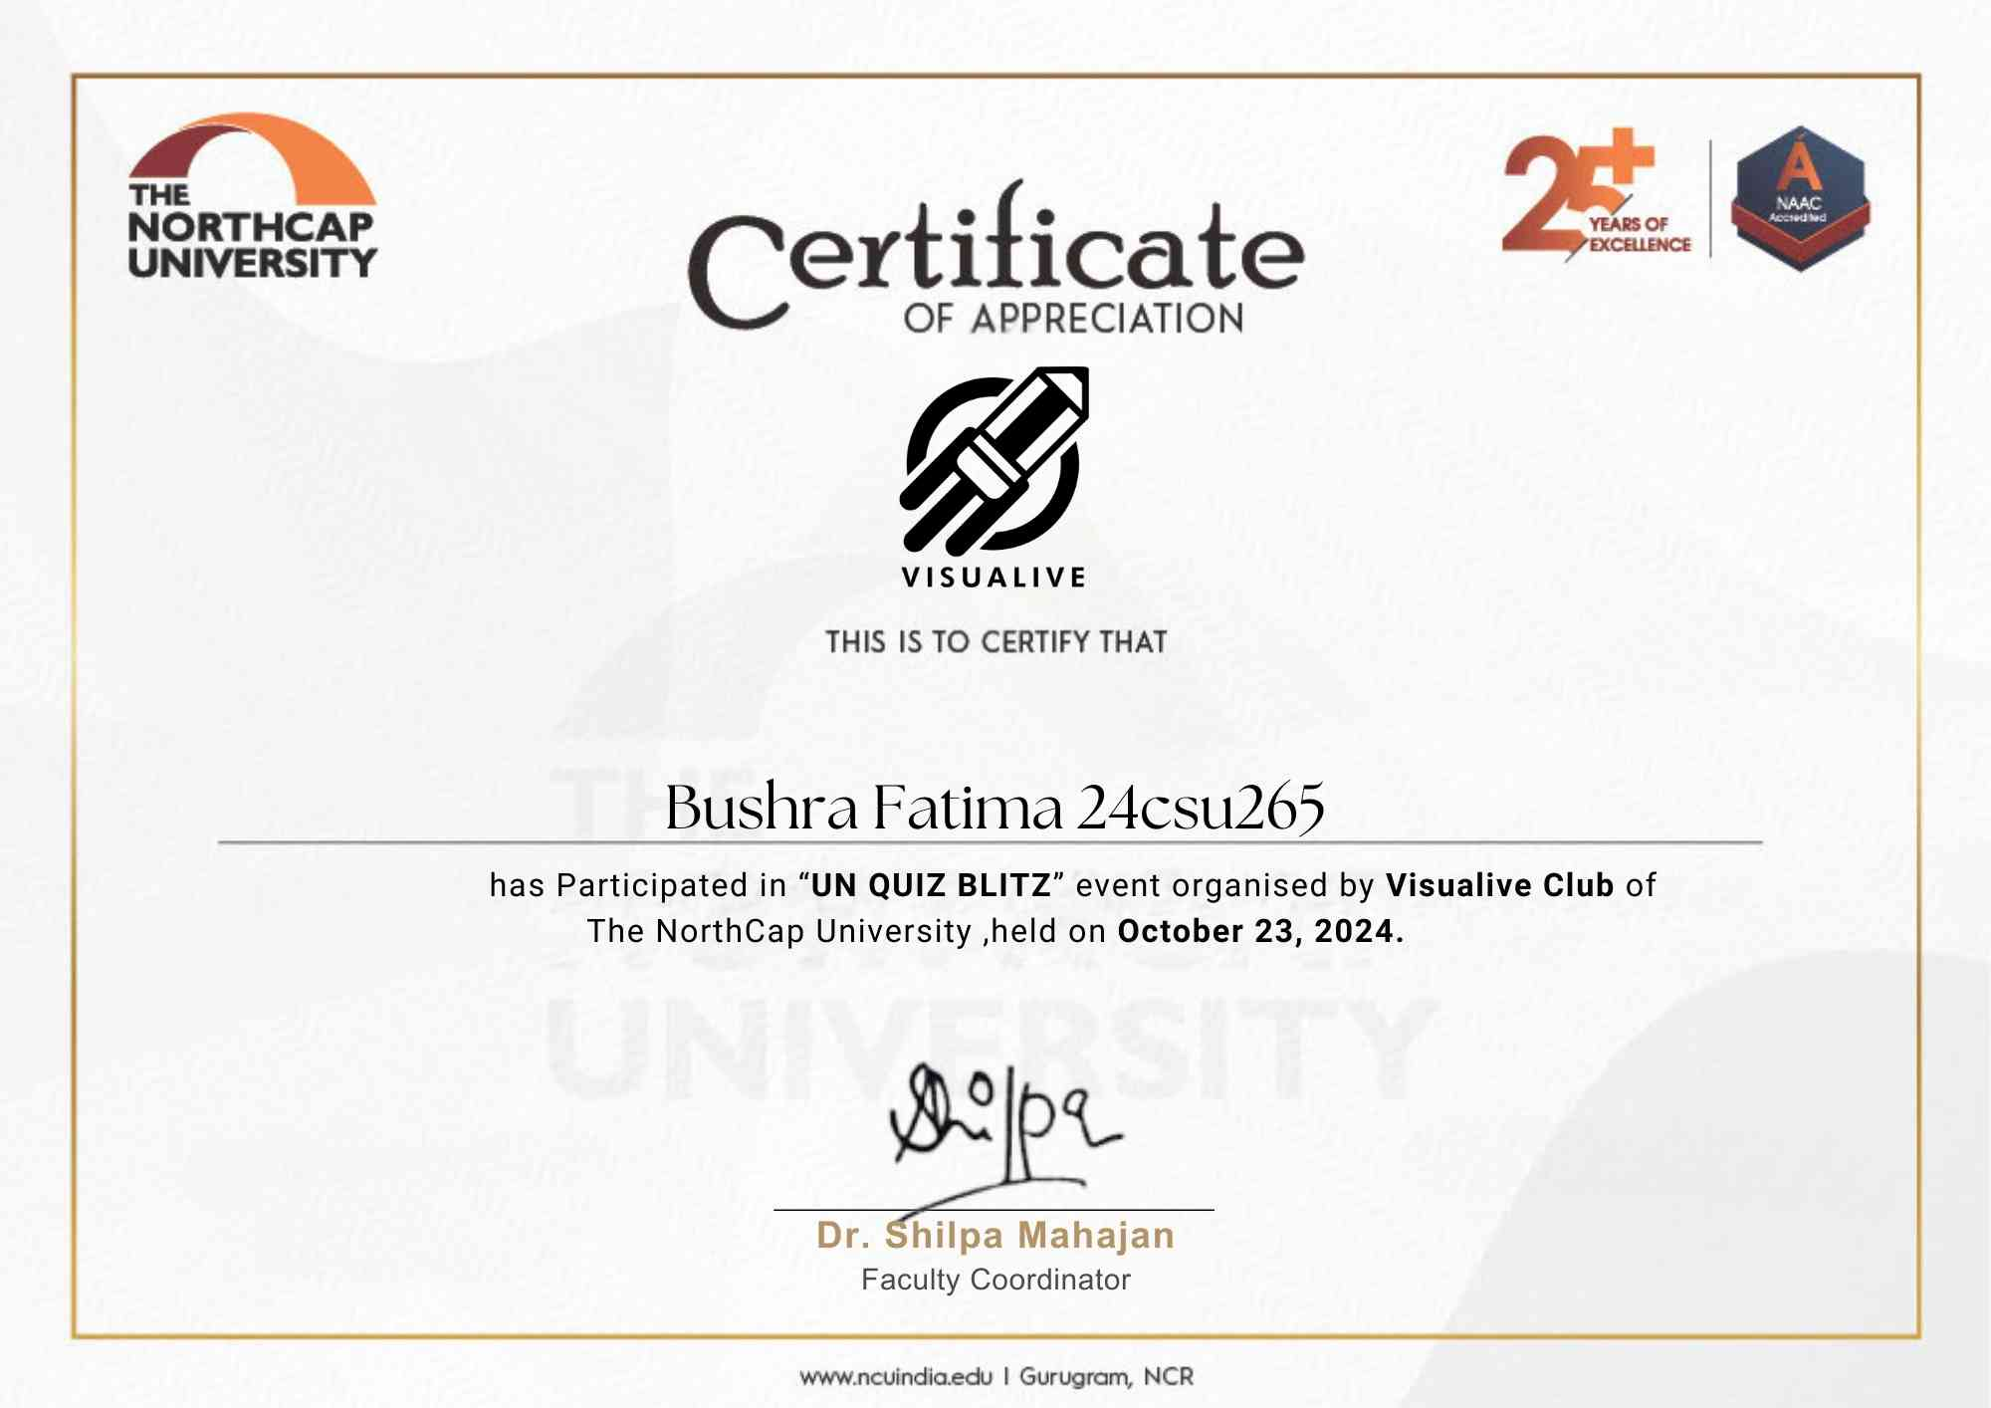

INDEX - Annexure TE2

Name of the Activity: **Find My Other Self Find My Other Self**

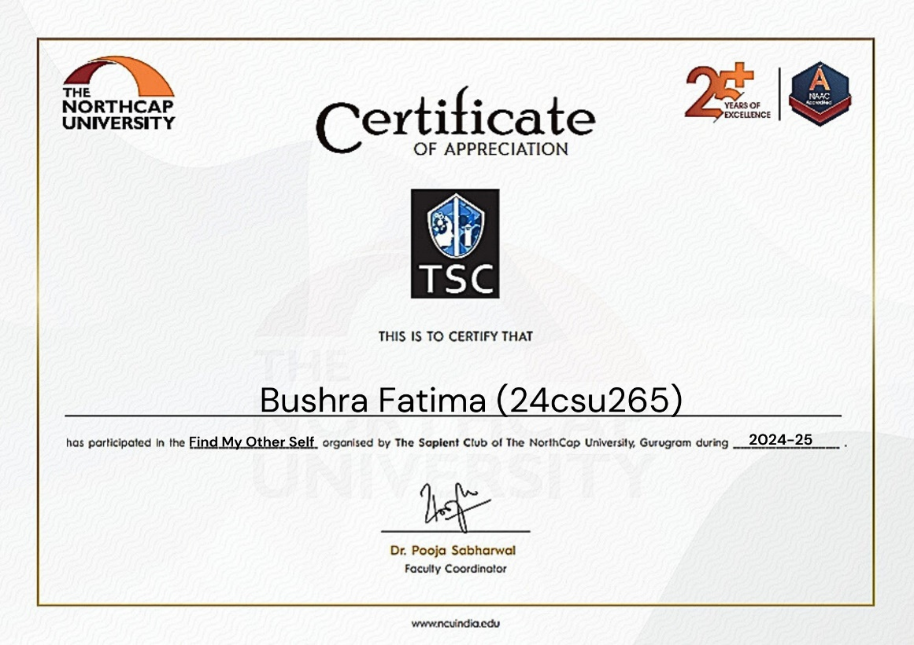

Name of the Activity: **Smiles And Sunshine NGO Visit**

INDEX - Annexure TE3

Name of the Activity: **NRC Guest Lecture**



Name of the Activity: **Astronomy Visit 2.0**

INDEX - Annexure TE4

Name of the Activity: **Green Innovation Unleashed**

Name of the Activity: **Green Innovation Unleashed (Coordinator)**

Name of the Activity: **Course on Calculations with vectors and Matrices**

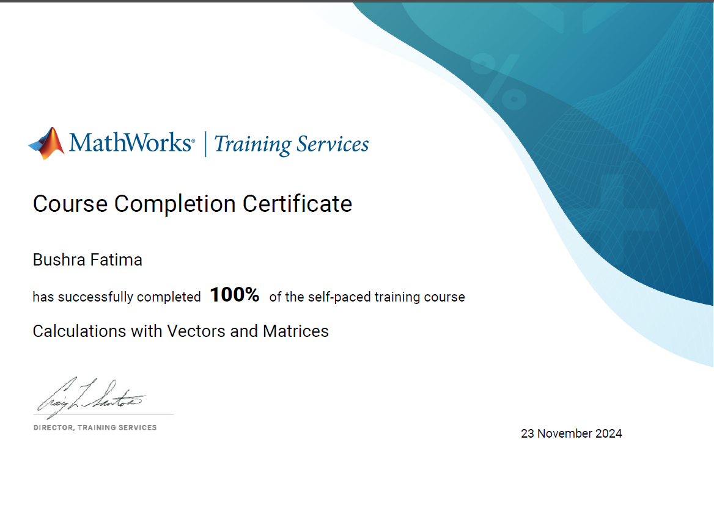

Name of the Activity: **Course on Calculations with vectors and Matrices**

